Session 1 -2

import java.util.*;
import java.io.*;

class BiCycle {
String define_me() {
return "a vehicle with pedals.";
}
}

class MotorCycle extends BiCycle {
String define_me() {
return "a cycle with an engine.";
}

MotorCycle() {
System.out.println("Hello I am a motorcycle, I am " + define_me());
String temp = super.define_me();
System.out.println("My ancestor is a cycle who is " + temp);
}
}

public class Solution {
public static void main(String[] args) {
MotorCycle M = new MotorCycle();
}
}
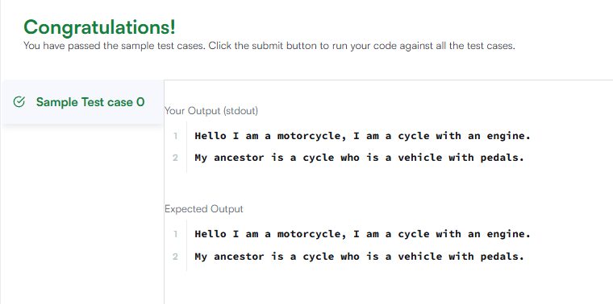

Session 1 -2

import java.util.*;
import java.io.*;

class BiCycle {
String define_me() {
return "a vehicle with pedals.";
}
}

class MotorCycle extends BiCycle {
String define_me() {
return "a cycle with an engine.";
}

MotorCycle() {
System.out.println("Hello I am a motorcycle, I am " + define_me());
String temp = super.define_me();
System.out.println("My ancestor is a cycle who is " + temp);
}
}

public class Solution {
public static void main(String[] args) {
MotorCycle M = new MotorCycle();
}
}


